# **SOCIAL MEDIA COOKING APP**

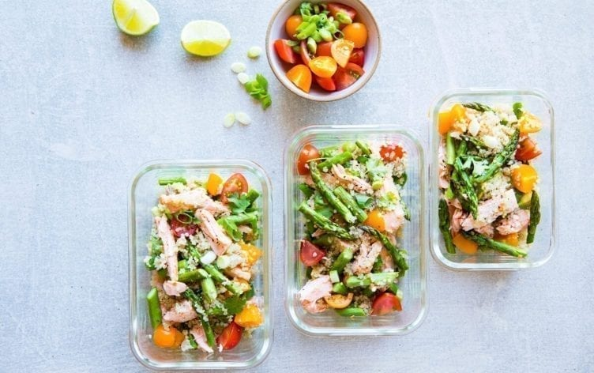

## *Figure 1: Krouse, L. (2020), Meal prep photo*

## REPORT

# 

Isha Kaur

ID: 31873588

**Contents**

k

**Introduction**………………………………………………………………………………......3

Background Information…...………………………………………………………….3

Target Audience……………………………………………………………………….3

**Analysis**……………………………………………………………………………………….4

Meal Prep Habits………………………………………………………………………4

User environment...……………………………………………………………………5

**Conclusion**…………………………………………………………………………………….6

**References**…………………………………………………………………………………….7

### **INTRODUCTION**

Having a balanced diet is very important when it comes to leading a healthy lifestyle, however due to a number of obstacles such as time, expenses and motivation, this can be a difficult habit to start or even maintain. The aim of the social media cooking app is to promote not only a healthier way of living, but also to make mealtimes fun, exciting and in addition, also possibly reduce food waste all whilst taking into consideration factors such as income and dietary requirements. In order to gain a better understanding of user’s habits and preferences when it came to meal prepping, a questionnaire was conducted and user responses were recorded and analysed.

**Background Information**

Studies show that there has been a decline in healthful eating and less people, especially young adults, now spend time cooking at home. This can be attributed to a number of factors, - “Cost barriers, stress, limited knowledge of how to prepare healthy foods, and taste preferences…” (Behav, A. J. H, 2012). The 23-to-38-year-old set also allocates less time to meal prep than their older counterparts. It doesn’t help that searching for recipes is no easy task. Multiple users complain that obtaining recipes is a tedious process due a multitude of reasons. In her blog post, “Why I hate searching for recipes online”, writer Jacqueline Conte shares her frustrations of searching for recipes online –“The recipe is at the very end of a very long blog post/photo shoot…the website is bogged down with advertisements…” (Conte, J. August, 2018). As a generation proven to display epidemic levels of stress and burnout, it’s no surprise convenience is chosen whenever possible.

**Target Audience**

The main focus group for this questionnaire was the general public. However, questionnaire findings show that majority of respondents were thirty years old or younger, with only 10.5% being above the age of thirty. The resulting age responses could be explained by the fact that the questionnaire was pinned on Facebook and was only viewable by immediate contacts of the distributor, making it less likely that users outside a similar age range would have the opportunity to respond. In the future, to obtain a more representative and accurate sample size, it would be beneficial to make the questionnaire available on other platforms and/or sources of media such as the newspaper and possibly even in person sessions.

With that being said, after conducting background research and analysing the questionnaire results it became startlingly transparent that the food app would be an especially effective product for users below the age of forty. As stated above, older generations seem to invest more time in meal prepping and cooking than their younger counterparts, so they would perhaps not benefit as much from the food app.

**ANALYSIS**

**Meal Prep Habits**

To gain an understanding of user habits when it came to meal prepping, respondents were firstly asked how often they participated in meal prep. The responses were fairly split, with approximately 57% of respondents already engaging in meal prep, leaving 43% of respondents who did not meal prep. A more important take on this was establishing how willing respondents, who did not currently meal prep, would be to give it a go. This resulted in an encouraging response, with 90% of non meal-preppers saying meal prep would be something they would be interested in trying. In addition to this, there was also a positive reception when asked if users would interested in trying new recipes as shown in the bar graph below.

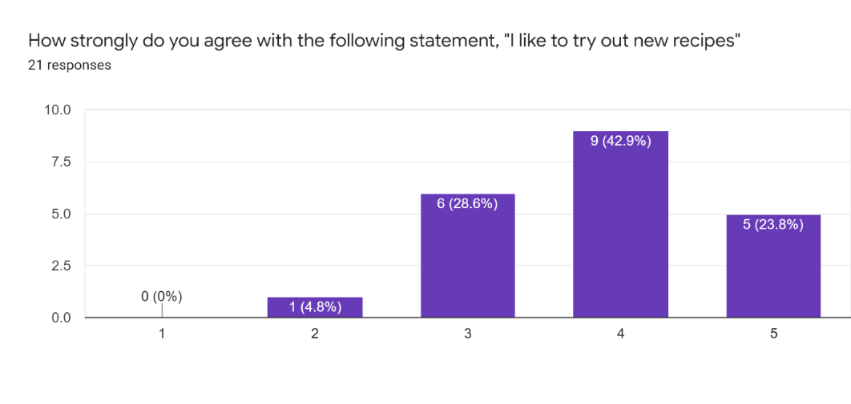

*Figure 3: Bar graph showing willingness of users to try out new recipes*

This shows that there is a positive reception to the idea of meal prepping and possibly indicates demand for meal prep tools which users could use to start and/or maintain existing meal prep habits.

One of the main focuses of the social media cooking app is not only to make meal prep easier and more exciting, but also to advocate a healthier lifestyle. For this reason, it was imperative to ask users, what obstacles prevented them from cooking healthy meals, if any. The findings were split into two categories. The first category addresses respondent’s complaints about having a lack of resources such as time and money, which prevented them from investing in healthier cooking. As shown in the graph below, time seemed to be the biggest issue when it came to prevention of meal satisfaction with almost 39% of respondents stating that they didn’t have enough time to cook. Most recipes online have a meal prep time available to give the reader an estimate on how long it will take them to make it, and the responses shown below indicate that it would be beneficial to include something similar when designing the food app in order to give users more control and flexibility.

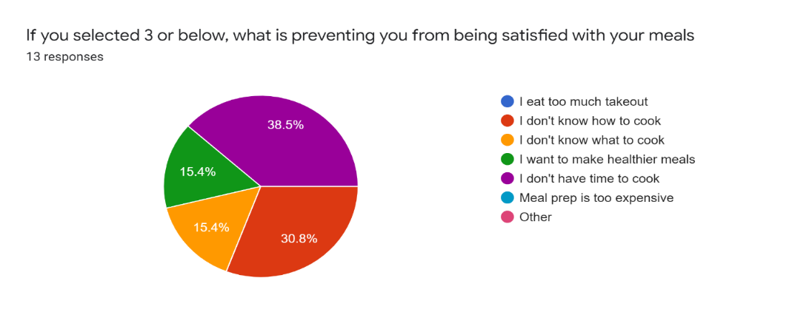

## *Figure 2: Pie Graph – What is preventing users from being satisfied with their meals?*

When asked about obstacles regarding healthy cooking, there was also general agreement around the fact that healthy cooking was relatively more expensive. However multiple studies show that this is a common misconception and claim that healthy cooking is not in fact as expensive as people tend to believe. For example, a study conducted by the Australian Prevention Partnership Centre explores the costs of healthy vs. unhealthy diets and findings showed that “healthy diets would be 12–15% cheaper than unhealthy diets” (Lee, A. February 2017). Taking this into consideration, it might be helpful to educate users to clear this misconception and have a price option available, further increasing user ease of use and satisfaction.

The second category addresses the enjoyment side of things i.e. motivation, skills, and satisfaction. A number of respondents claimed that healthy cooking was not as emotionally rewarding as junk food – “A lot of the time healthy meals aren’t as yum”, and in addition to this, healthy meals could often become repetitive and boring – “repetition of consuming the same meals”. Some participants also stated that they felt they didn’t have the skills required to make healthy meals stating that they were “really bad at cooking” and felt that healthy cooking equated to more complex recipes.

**User environment**

In order to maximise positive user experience, it is important to get a thorough understanding of the user’s expectations of the use/anticipated use of the food app. This means taking into consideration the user’s personal lifestyle. To account for this, the questionnaire included responses detailing user’s personal attributes including weekly grocery budget and dietary requirement. The findings showed that majority of respondents (61.9%), spent less than $100 on groceries per week. Questionnaire findings also showed that over 71% of users stated that they had special dietary requirements.

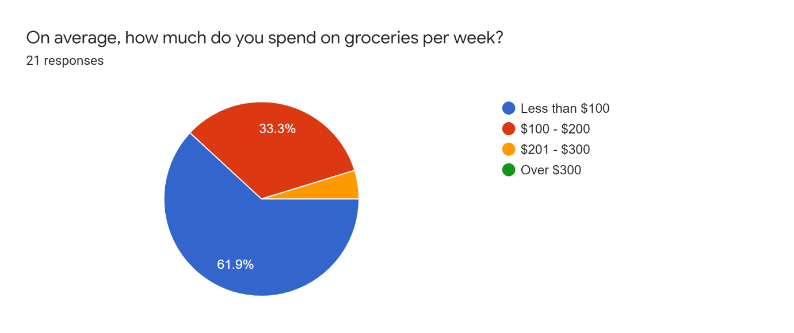

*Figure 4: Pie Graph representing weekly grocery expenditure*

Both of these are important factors to consider when designing the app as it reflects upon important aspects of the user’s demographics. So in order to appeal to users and increase ease of use and satisfaction, we must account for user’s budget and any special dietary requirements they may have.

**CONCLUSION**

To gain an understanding of the user’s demographics, it was important to get an understanding of their existing habits, in order to more effectively tailor and align the app’s purpose with what the user wanted. The most important thing perhaps was to gain an idea of whether or not there would be a demand for the app, and this was proven to be true upon finding out that even though almost 50% of respondents did not meal prep, meal planning and trying out new recipes was in fact something they would be interested in trying.

After this initially positive response, it was necessary to tackle the underlying issues of why users did not currently participate in meal prep, or what prevented them from being fully satisfied with their mealtimes. The questions allowed direct feedback regarding respondent’s opinions about said topics, allowing a deeper insight into user’s perspectives. It was surprising to see how receptive respondent’s were to the idea of trying new recipes, despite the evident barriers they faced in doing so.

For future changes, it would be more effective to get rid of the questions regarding takeout history as it did not seem to provide any real value in regard to understanding user behaviours. Instead, it would perhaps be more helpful to question users about their thoughts and opinions on current methods of recipe searching i.e. accessing recipes online, through cookbooks etc. and what barriers they faced in doing so. This would have been more effective as it would allow a more thorough inspection of the flaws evident in competitor products that were currently available on the market and allow investigation of possible solutions to said issues.

**REFERENCES**

1. Behav, A. J. H. (2012), *Work Hours and Perceived Time Barriers to Healthful Eating Among Young Adults*, PMC, <https://www.ncbi.nlm.nih.gov/pmc/articles/PMC3464955/>
2. Chen, J. (2020), *Social media demographics to inform your brand’s strategy in 2020,* SproutSocial, <https://sproutsocial.com/insights/new-social-media-demographics/>
3. Conte, J. (August, 2018), *Why I Hate Searching for Recipes Online*, JMC, <https://www.jacquelinemayconte.com/blog/2018/7/25/why-i-hate-searching-for-recipes-online>
4. Krouse, L. (2020), *6 Proven Ways to Get Out of a Meal Prep Plateau,* MyFitnessPal,<https://blog.myfitnesspal.com/6-proven-ways-to-get-out-of-a-meal-prep-plateau/>
5. Lee, A. (February 2017), *Are healthy diets really more expensive,* Australian Prevention Partnership Centre, <https://preventioncentre.org.au/wp-content/uploads/2017/03/1702_FB_LEE_4p_final_lr.pdf>
6. Persona 1 image - Zhou, C. (2016), *Meet the female leaders in Melbourne’s property industry,* Domain, <https://www.domain.com.au/news/meet-the-female-leaders-in-melbournes-property-industry-20160307-gn83p3/>
7. Persona 2 image – Dam, M. Unsplash, <https://unsplash.com/photos/mEZ3PoFGs_k>
8. Persona 3 image – Hayes. G. Unsplash, <https://unsplash.com/photos/2guarBycJJQ>

**USER STORIES**

1. As someone that does not engage in meal prep, I want to expand my cooking skills so that I can be more creative with my meal choices

*Acceptance criteria:*

* Helpful tips and recommendations included to assist user.
* Daily recipe suggestions based on user preferences to encourage creativity in meal prep

1. As someone that does not engage in meal prep, I want access to recipes that don’t involve complex ingredients/instructions so that I can be more flexible with my meal choices using just the items in my pantry.

*Acceptance criteria:*

* Option to filter/filter out recipes which use certain ingredients/tools
* Substitute recommendations to increase user flexibility

1. As someone less skilled in cooking, I want recipes that are easy to make so that I can learn new cooking skills

*Acceptance criteria:*

* Difficulty level is displayed for each recipe so user can select one that fits their skillset.
* Step by step instructions that are easy to follow

1. As someone less skilled in cooking, I want recipes that are easy to make so that I can build healthier eating habits.

*Acceptance criteria:*

* Difficulty level displayed for each recipe
* Filters available for categories i.e. suitable for users who are opting for healthier choices etc.

1. As a vegetarian/vegan, I want to be able to more easily access recipes that suit my lifestyle, so mealtimes aren’t as boring

*Acceptance criteria:*

* Filters available to select recipes available for users with specific dietary requirements.

1. As a busy, full-time worker, I want to have access to quick recipes so that I can make mealtimes more exciting without the added cost of taking up too much of my time.

*Acceptance criteria:*

* Cooking times available on each recipe to suit user’s needs
* Filtering of cooking time available to suit busy users

1. As a busy, full-time worker, I want a range of recipes easily accessible in one place so that I don’t waste lots of time scrolling through different pages trying to find a recipe that suits my preferences.

*Acceptance criteria:*

* Layout similar to apps such as tinder/tiktok, involving quick swiping to select recipe to fit user’s preferences. Fun and quick way to search for new meal ideas.

1. As a busy full-time worker, I want to have easy access to a range of recipes so that it’s easier for me to decide on what to cook.

*Acceptance criteria:*

* Recipes collected and compiled from a number of databases, and presented to user in a compact, easy to use format, layout similar to apps like tinder/tiktok

1. As a busy full-time worker, I want to be able to easily meal prep and organise recipes so that I spend less time and money on grocery shopping

*Acceptance criteria:*

* Recipes include list of ingredients so easy to plan and shop for all ingredients at one time
* Option to save recipes – allows for easy organisation and planning

1. As a parent, I want a range of healthy recipes so that I can help my children build positive eating habits.

*Acceptance criteria:*

* Option to filter recipes in terms of categories, e.g. users can choose to view only healthy recipes which are more suited to their lifestyle

1. As a parent, I want a range of yummy and nutritious recipes so that my children can enjoy mealtimes

*Acceptance criteria:*

* Large number of options available allows for creative freedom and flexibility in meal planning

1. As a junk-food lover, I want recipes that are healthier, without compromising the yummy factor, so that I can establish healthier dietary habits

*Acceptance criteria:*

* Large number of options available allows for creative freedom and flexibility in meal planning

1. As a student I want more recipes that are quick and easy to make so that I spend less money on takeout.

*Acceptance criteria:*

* Recipes contain ingredient list, allowing for easy budget control
* Recipes can also be filtered in terms of price range/complexity, similar to how uberEats filter restaurants in terms of price

1. As a student, I want recipes that are quick and easy to make so that I can be more creative in my meal prep choices without spending too much time/energy on it

*Acceptance criteria:*

* Large number of options available allows for creative freedom and flexibility in meal planning
* Time filtering available, allows for customisation of which recipes to view.

1. As a student, I want recipes that are quick and easy to make so that I can build on my cooking skills and become a more independent individual

*Acceptance criteria:*

* Tips and recommendations available with recipes to aid users with less confidence
* Easy to follow step by step instructions

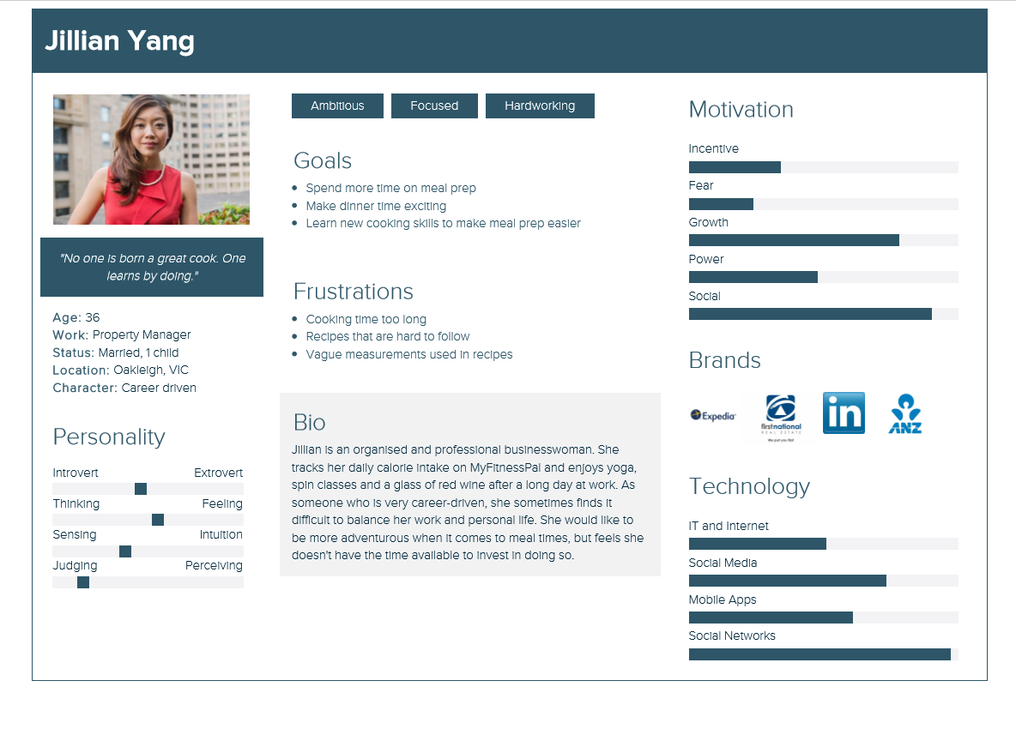

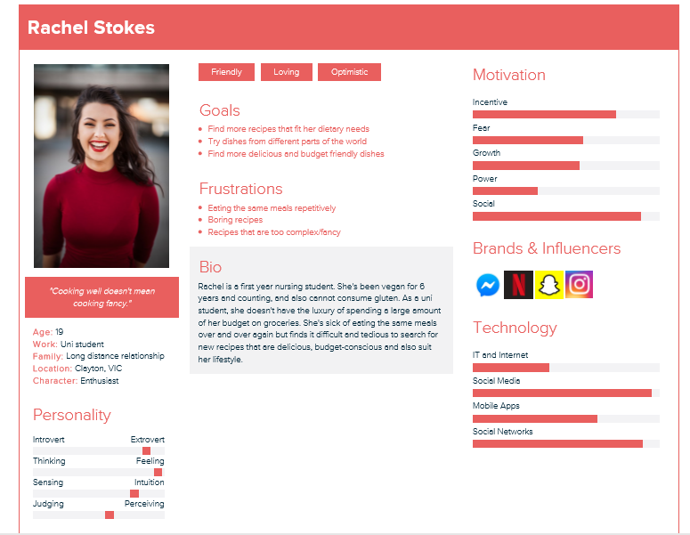

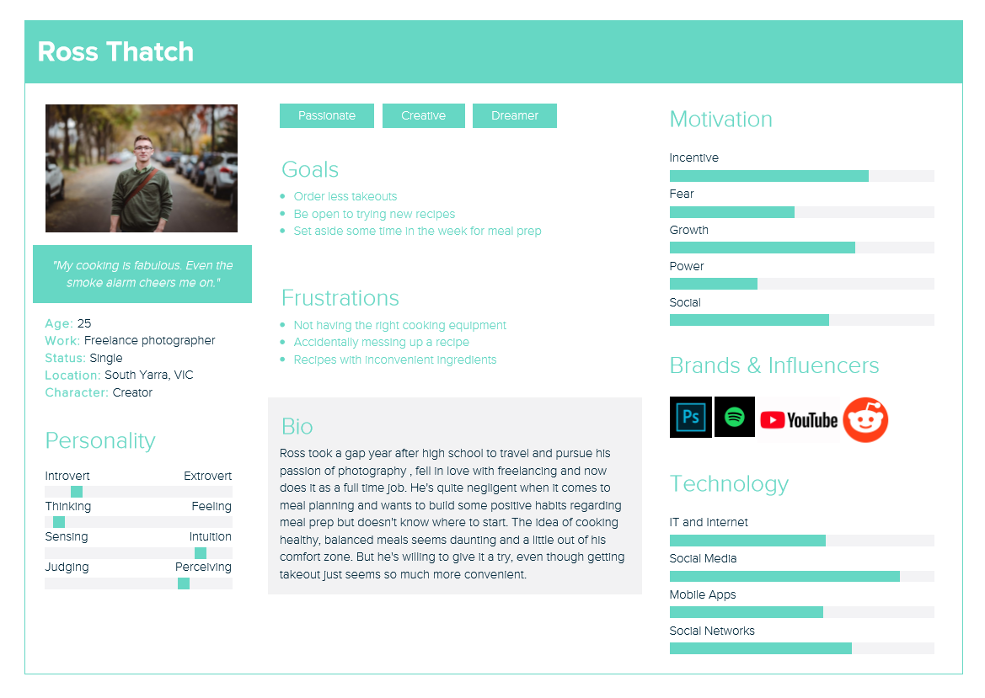QUESTIONNAIRE RESULTS:

